RESOLUTION NO.__________

RE: CERTIFICATE OF APPROPRIATENESS UNDER THE
PROVISIONS OF THE ACT OF THE PENNSYLVANIA
LEGISLATURE 1961, JUNE 13, P.L. 282 (53
SECTION 8004) AND BETHLEHEM ORDINANCE NO.
3952 AS AMENDED.

The applicant proposes to install a sign at 91 W. Broad St. (Yaralov Gallery).

NOW, THEREFORE, BE IT RESOLVED by the Council of the City of Bethlehem that a Certificate of Appropriateness is hereby granted for the proposal.

Sponsored by: (s)

(s)

ADOPTED BY COUNCIL THIS DAY OF

(s)
President of Council

ATTEST:

(s)
City Clerk

HISTORICAL & ARCHITECTURAL REVIEW BOARD

The applicant proposes to install a sign at 91 W. Broad St.
(Yaralov Gallery).

APPLICATION #5:
Walk In

Sun Inn
564 Main St.
Bethlehem, PA 18018

OWNER:

__________________________________________________________________________

The Board upon motion by Connie Postupak and seconded by Connie Glagola adopted the proposal that City Council issue a Certificate of Appropriateness for the following:

- Connie Postupak and Fred Bonsall are to meet and select the color to re-paint all
vertical surfaces to match the top flat sign.

2. Approved the sign to be maroon with gold and leaf lettering.

3. The motion was unanimously approved.

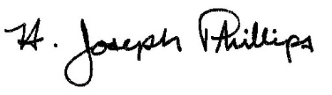 By:__H. Joseph Phillips___________

Title: __Historic Officer____________

Date of Meeting: October 3, 2018

